

**BEACONHOUSE NATIONAL UNIVERSITY**

**SaafPakistan**

**PRJ-F23/329**

**PROJECT PROPOSAL REPORT**

**EXTERNAL SUPERVISOR**

**Mr. Abdul Wahab**

**INTERNAL SUPERVISOR  
  
 Ms. Shazia Rizwan**

**GROUP MEMBERS**

**Ali Sher F2020-158**

**Nouman Ali F2020-149**

**Mian Faizan Munawer F2020-148**

**SCHOOL OF COMPUTER & IT**

**September 2023**

**Contents**

**Problem Statement: 3**

**Existing Systems 3**

**Literature Survey 4**

**Additional Research 5**

**Solution 9**

**User Roles 10**

**User Stories 10**

**Use Case Diagram 13**

**Functional Requirements 14**

**1. SaafPakistan Mobile App 14**

**2. SaafPakistan Web App 32**

**Non-functional Requirements 42**

**Test Cases 43**

**1. Test Cases for Mobile App (FR1.1 to FR1.28) 43**

**2. Test Cases for Web App (FR2.1 to FR2.19) 58**

**References 69**

# 

# 

# 

# 

# 

# 

# **Problem Statement:**

In Pakistan, the absence of a structured recycling system, marked by the absence of separate bins for recyclables, has led to a widespread habit of indiscriminate waste disposal. This contributes significantly to environmental pollution and the buildup of recyclable materials in landfills. The problem is intensified by a lack of awareness among the public about the environmental consequences and the absence of incentives to promote responsible waste management. The absence of initiatives addressing these issues not only worsens environmental pollution but also hinders the sustainable utilization of valuable recyclable resources.

# **Existing Systems**

In Lahore, Pakistan, the prevailing waste management system heavily relies on informal and inconsistent practices. Residents and businesses typically dispose of their waste by dumping it in open areas, streets, or makeshift trash piles near their homes or places of business. These haphazard disposal methods often result in unsightly, unsanitary, and environmentally harmful conditions.

The collected waste is typically gathered by local waste collector or municipal workers who manually sort through it to salvage recyclable materials. Non-recyclable waste is then transported to landfills, which are often poorly managed and insufficiently regulated, leading to pollution and health hazards. Households in Lahore rarely segregate waste, with organic and inorganic materials tossed in together. This means that otherwise recyclable materials, such as paper and plastic, become contaminated with bacteria, reducing their quality and usefulness.

Even if waste was segregated at the basic level with separate bins for organic and inorganic waste, we could significantly reduce the amount of garbage that ends up in landfill sites in Lahore. Due to the absence of a well-structured recycling system, valuable recyclable resources are frequently mixed with non-recyclable waste, exacerbating environmental issues.

An NGO Aabroo Educational Welfare Organization, based in Lahore, has recognized the need for sustainable waste management solutions and has taken a pioneering step in this direction. Since 2007, they have initiated a successful Solid Waste Management Initiative, collecting recyclable waste from households and institutions. This program not only generates funds to support the organization but also promotes environmental awareness with a focus on the 3Rs (Reduce-Reuse-Recycle). Currently serving around 7,000 households and 28,000 donors each month, the initiative covers one-third of Aabroo's monthly expenses, with the goal of achieving full financial sustainability in the near future.

Still, there is a lack of incentives for responsible waste management in Lahore, discouraging individuals and businesses from actively participating in recycling efforts. These challenges highlight the urgent need for a comprehensive and organized waste disposal and recycling solution in Lahore, such as SaafPakistan.

# **Literature Survey**

As we look for smart ideas to encourage good habits and positive results, we've been reading a bunch of research papers and articles. One interesting thing we found is gamification, which means using game-like features in non-game situations. We're also really interested in tools like carbon footprint calculators that help figure out how our actions affect the environment. By checking out lots of information, we've learned that combining these game ideas with tools like carbon calculators could help make our future more sustainable.

* A study "Gamification for Recycling: A Review of the Literature" by the University of California, Berkeley (2020) found that gamification can also be effective at increasing recycling rates. The study found that a program that rewarded people with points for recycling led to a 15% increase in the recycling rate.[1]
* A study "Financial Incentives and Gamification to Increase Recycling Rates" by the World Bank (2021) found that financial incentives and gamification are most effective at increasing recycling rates in countries with high levels of income and education.[2]
* The article "The state of carbon footprint calculators: An evaluation of calculator design and user interaction feature by John Mulrow" is about the state of carbon footprint calculators. It discusses the growing interest in these tools and the variety of calculators available. The authors note that there is no standardization in the way calculators are designed or the data they use. This makes it difficult to compare results from different calculators. The authors also discuss the importance of user engagement and how calculators can be used to educate people about their carbon footprint.[3]
* Gamification is a promising approach to promoting tourist recycling behavior, as shown in the article "Gamification as An Approach to Promote Tourist Recycling Behavior" by Lidia Aguiar-Castillo et al. (2019). It can make recycling more fun and engaging for tourists, and encourage them to recycle more often. Some examples of gamification for tourist recycling include awarding points and badges, using leaderboards, and creating challenges.[4]

In light of these research findings, it becomes evident that targeted strategies, such as gamification and financial incentives, hold the power to significantly enhance recycling rates. Furthermore, standardizing the design and features of carbon footprint calculators remains crucial. This not only facilitates precise environmental impact assessment but also functions as an educational instrument, guiding individuals toward more responsible and sustainable behaviors. Collectively, these approaches offer a promising pathway toward a more sustainable and environmentally-conscious future.

# **Additional Research**

**1.** **Recycle Coach Mobile App** **[5]**

Recycle Coach is a mobile app and website that helps users recycle and compost correctly. It provides information on what materials can be recycled or composted in their area, as well as tips on reducing waste. Recycle Coach also has a feature that allows users to set reminders for their recycling and composting pickup days.

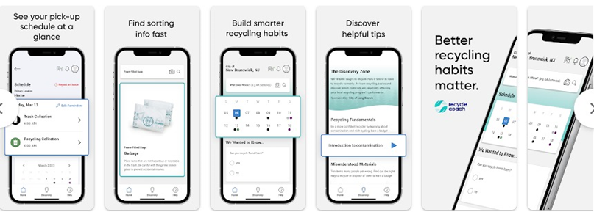

Figure 1 Recycle Coach App Preview

**2.** **iRecycle Mobile App [6]**

iRecycle is another mobile app that helps users recycle and compost correctly. It provides similar information to Recycle Coach, but it also has a few additional features, such as a barcode scanner that can be used to identify recyclable materials. iRecycle also has a rewards program that gives users points for recycling and composting, which can be redeemed for prizes.

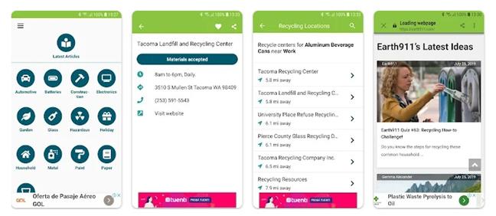

Figure 2 iRecycle Mobile App Preview

**3.** **Recycle Smart Mobile App [7]**

Recycle Smart is a mobile app that provides information on what materials can be recycled, as well as tips on reducing waste. Recycle Smart also has a feature that allows users to find the nearest recycling drop-off location.

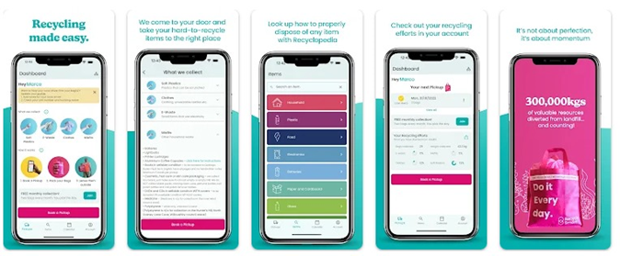

Figure 3 Recycle Smart Mobile App Preview

**4.** **Zeloop Mobile App [8]**

ZeLoop is a mobile app that rewards users for collecting and recycling plastic bottles. It is a great way to reduce plastic pollution and earn rewards at the same time. The app guides users to collection points near them, where they can drop off their plastic bottles and take a picture to earn Eco Rewards tokens. Eco Rewards tokens can be exchanged for a variety of prizes, including gift cards, merchandise, and even donations to environmental charities.

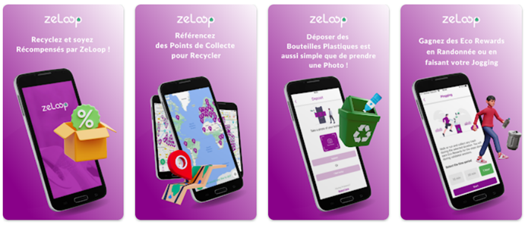

Figure 4 Zeloop Mobile App Preview

**5.** **The Click Mobile App [9]**

The Click is a Belgian app that rewards users for disposing of their waste properly and picking up litter. Users can scan QR codes on waste bins to receive Circular UCoins, which can be redeemed for discounts and rewards at participating merchants.

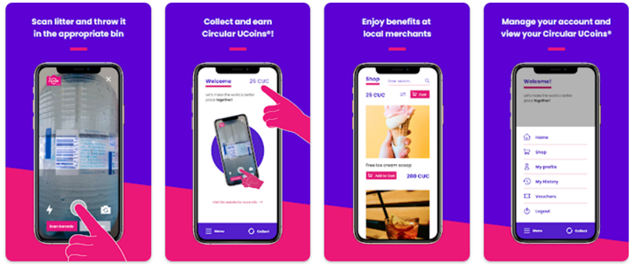

Figure 5 The Click Mobile App Preview

**6.** **Gaia Mobile App [10]**

Gaia is gamified recycling app that uses machine learning to provide users with recycling information based on the item they scan. The app would reward users for recycling correctly with points that can be redeemed for rewards. This would make recycling more engaging and rewarding, and help to increase recycling rates and reduce waste.

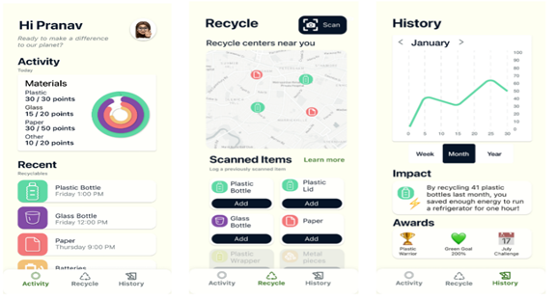

Figure 6 Gaia Mobile app Preview

The problem with these systems is that they are not available in Pakistan.

# **Solution**

SaafPakistan is a revolutionary mobile application designed to transform waste management and recycling practices in Pakistan. It tackles the challenges posed by unstructured waste disposal while promoting responsible recycling habits among both individuals and businesses. Here are the key features of this innovative solution:

**1.** **Recycling Pickup Scheduling:** The app empowers users to effortlessly schedule pickups for recyclable materials, making it convenient and accessible for everyone to participate in recycling.

**2.** **Gamification Leaderboard System:** To inspire a sense of competition and engagement, the app integrates a dynamic leaderboard system for both individuals and businesses. Users earn points and rankings based on their recycling activities, and real-time updates keep them motivated and involved.

**3.** **Add Friends and Friends Leaderboard:** Users can connect with others on the platform by sending and accepting friend requests. Once connected, they can view a separate "Friends Leaderboard" to compare their recycling achievements with their friends.

**4. Rewards and Compensation:** To encourage continued participation, users receive monetary compensation for their contributions to recycling. The app provides transparent and real-time tracking of users' earnings, keeping them informed about their achievements in terms of monetary rewards.

**5.** **Corporate Onboarding:** Companies can register to participate in the recycling program, extending the gamification aspect to the corporate sector. This feature allows businesses to showcase their environmental initiatives and commitment to sustainability through the app.

**6.** **Advertisement as a Green Company:** Businesses actively participating in the program receive recognition as eco-friendly and socially responsible partners. This heightened visibility can attract environmentally conscious consumers, potentially leading to increased customer engagement.

**7.** **Educational Content:** The app includes educational content like tips and tricks to guide users on how to recycle effectively and why it matters.

**8.** **Dashboard Summary:** Users are presented with a motivating summary on their dashboard, which encourages them to earn more points and recycle more. The summary includes details such as the total amount they have earned, the total number of waste items recycled, and the total reduction in carbon emissions, offering a clear view of their positive environmental impact.

Our aim is to develop an app that not only streamlines waste management and recycling but also raise awareness about responsible waste disposal and show the importance of sustainability practices.

# **User Roles**

SaafPakistan app involves the following user roles

**Customer:** A user who is an individual or corporate organization looking to recycle waste.

**Rider:** A user who uses the system as a rider to complete recycling pickups.

**Warehouse Manager:** A user who uses the system as a warehouse manager to oversee recycling pickups at the warehouse.

**Admin:** A user with administrative privileges who manages and oversees the entire system.

# 

# **User Stories**

**User Story 1:** Scheduling a Pickup for Recycling

As an environmentally-conscious customer, I want the ability to schedule a pickup for recycling from my desired location, so that I can conveniently and responsibly dispose of my recyclable materials.

**Acceptance Criteria:**

· When I access the Recycling App, I should find a user-friendly option on the main screen that allows me to schedule a pickup.

· I can select a "Schedule Pickup" button, which prompts me to enter details for the pickup request.

· I should have the option to specify the types of materials I want to recycle, such as paper, plastic, glass, or other recyclables.

· The app should prompt me to specify my pickup address, either by manually entering the address or selecting it from a list of saved addresses.

· After entering the details and confirming my pickup request, the app should provide a confirmation notification.

· If I need to cancel the pickup request, I should have the option to do so within the app.

**Prototypes**

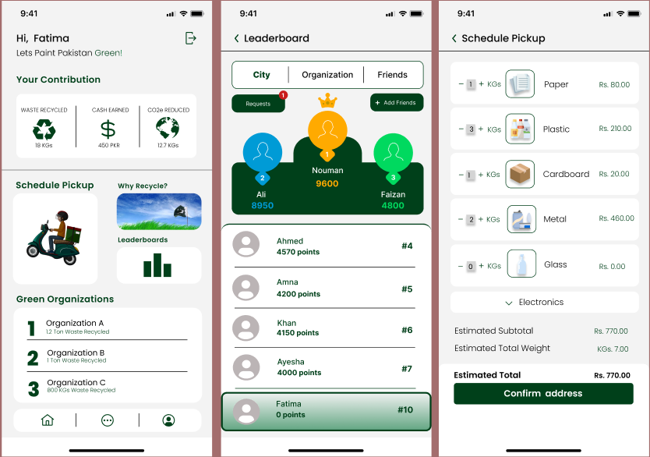

Figure 7 SaafPakistan Customer’s App prototypes

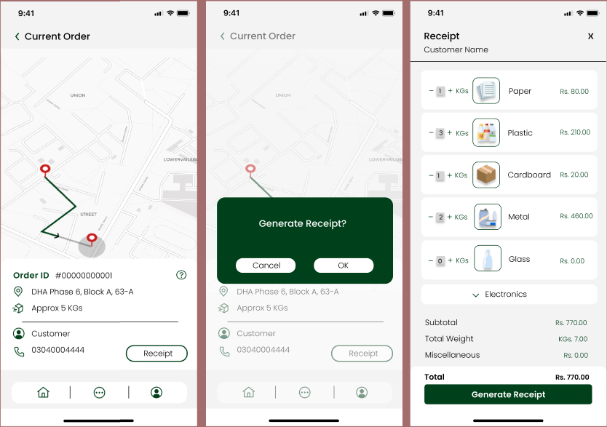

Figure 8 SaafPakistan Rider’s App prototypes

# 

# **Use Case Diagram**

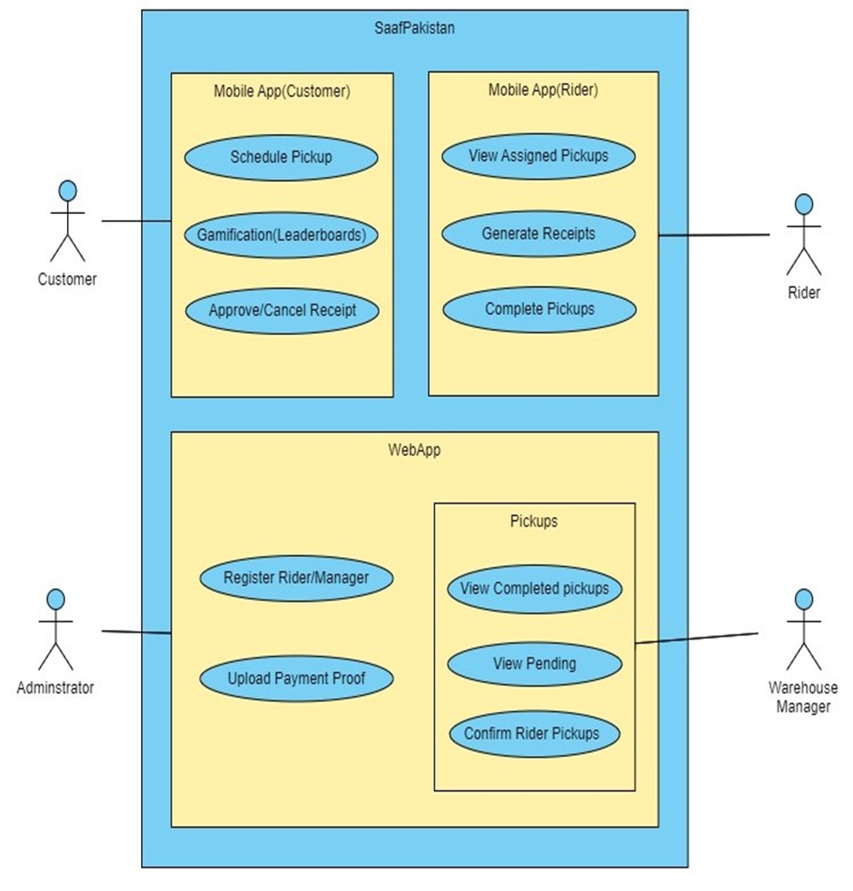

# 

# **Functional Requirements**

# **1. SaafPakistan Mobile App**

**Customer Requirements**

**FR1.1: Customer Registration**

· **Description**: The system shall allow the customer to register an account.

· **Actors**: Customer

· **Precondition**: Customer is not registered in the system.

· **Postcondition**: Customer is registered in the system and directed to the home page.

· **Main Flow:**

1. Customer provides valid registration information, including name, email, phone number, and selects whether the account is personal or for a company.

2. The system validates the information and ensures it is unique.

3. User account information, including the chosen account type (personal or company), is securely stored in the database.

· **Alternate Flow**: Registration information is invalid or not unique, and the system provides an error message.

**FR1.2: Customer Sign In**

· **Description**: The system shall allow the customer to sign in to account.

· **Actors**: Customer

· **Precondition**: Customer is not logged in.

· **Postcondition**: Customer is logged in and gains access to their account.

· **Main Flow:**

1. Customer provides valid email and password.

2. The system validates the customer's credentials.

3. Upon successful validation, the customer is granted access to their account.

· **Alternate Flow**: Customer provides invalid credentials, and the system denies access.

**FR1.3: Customer Logout**

· **Description**: The system shall allow the customer to log out of their account.

· **Actors**: Customer

· **Precondition**: Customer is logged in.

· **Postcondition**: Customer is logged out of their account.

· **Main** **Flow**:

1. Customer selects the logout option.

2. The system logs the customer out and redirects them to the login screen.

· **Alternate Flow:** None

**FR1.4: View Account Profile**

· **Description**: The system shall allow the customer to view their account profile.

· **Actors**: Customer

· **Precondition**: Customer is logged in.

· **Postcondition**: Customers can view their name, phone number, email, and address in their account profile.

· **Main Flow:**

1. Customer selects the profile icon.

2. The system displays the customer's account profile information, including:

o Name

o Phone number

o Email

o Address

o Map location

· **Alternate Flow:** None

**FR1.5: Update Profile**

· **Description**: The system shall allow the customer to update profile.

·  **Actors**: Customer

· **Precondition**: Customer is logged in.

· **Postcondition**: Customers can edit their account information, including name, email, phone number, address, and password.

· **Main Flow**:

1. Customer selects the profile icon.

2. The system displays the customer's current profile information.

3. Customer selects the “Edit Profile” option.

4. The system shall allow the customer to update their name, email, phone number, address, and password.

5. Customer makes the desired changes.

6. The system validates the changes and updates the customer's account information.

· **Alternate Flow 1:** The customer provides invalid information, and the system displays an error message.

· **Alternate Flow 2:** The customer decides not to make any changes and cancels the editing process.

**FR1.6: Schedule Pickup for Recycling**

· **Description**: The system shall allow the customer to schedule pickup for recycling.

· **Actors**: Customer

· **Precondition**: Customer is logged in.

· **Postcondition**: The pickup is scheduled, and the recycling pickup request is recorded.

· **Main Flow**:

1. Customer clicks the “Schedule Pickup” button.

2. Customer is presented with a list of recyclable items.

3. Customers enter the estimated weight of each recyclable item that they want to recycle.

4. The system calculates the estimated total price for the recyclables based on the recyclable items and their weights.

5. The system shows the estimated pickup time and the customer's address.

6. Customer confirms the pickup by clicking “Confirm pickup”.

7. The system records the pickup recycling pickup request and provides a confirmation to the customer.

· **Alternate Flow 1**: the total weight is less than minimum limit set by admin, the system displays an appropriate message indicating that the minimum weight requirement for pickup is not met, and the pickup is not scheduled.

· **Alternate Flow 2**: Customer decides not to proceed with the pickup scheduling.

**FR1.7: View Current Recycling Pickup Request**

· **Description**: The system shall allow the customer to view current recycling pickup requests.

· **Actors**: Customer

· **Precondition**: Customer has a scheduled recycling pickup request.

· **Postcondition**: Customer can view details of the current recycling pickup request.

· **Main Flow**:

1. Customer selects the “View Current recycling pickup request” option.

2. The system displays details of the current recycling pickup request.

· **Alternate Flow:** None

**FR1.8: Cancel Current Recycling Pickup Request**

· **Description**: The system shall allow the customer to cancel the current recycling pickup request.

· **Actors**: Customer

· **Precondition**: Customer has a scheduled recycling pickup request.

· **Postcondition**: Customer recycling pickup request is canceled.

· **Main Flow**:

1. Customer selects the “View Current recycling pickup request” option.

2. The system displays details of the current recycling pickup request.

3. Customer clicks “Cancel recycling pickup request”.

· **Alternate Flow:** None

**FR1.9: View Pickup History**

· **Description**: The system shall allow the customer to view their recycling pickup history.

· **Actors**: Customer

· **Precondition**: Customer is logged in.

· **Postcondition**: Customers can view their pickup history.

· **Main Flow**:

1. Customer selects the “Recycling History” option.

2. The system displays a list of past recycling pickups.

· **Alternate Flow:** None

**FR1.10: View Pending/Paid Payments**

· **Description**: The system shall allow the customer to view their pending and completed payments for recycling services.

· **Actors**: Customer

· **Precondition**: Customer is logged in.

· **Postcondition**: Customer can view payment status.

· **Main Flow**:

1. Customer selects the “Recycling History” option.

2. The system displays a list of recycling pickup requests in the customer's history, and for each recycling pickup request, it indicates the payment status, whether it's pending or paid.

· **Alternate Flow:** None

**FR1.11: View Recycling Statistics on Home Page**

· **Description**: The system shall allow the customer to view total waste recycled, cash earned and carbon emission reduced on the home page.

· **Actors**: Customer

· **Precondition**: Customer is logged in and on the home page.

· **Postcondition**: Customers can view total waste recycled, cash earned and carbon emission reduced.

· **Main Flow**:

1. Customer visits the home page.

2. The system displays:

o Amount of waste recycled

o Cash earned through recycling

o Carbon emissions reduced through recycling

· **Alternate Flow:** None

**FR1.12: View Top 3 Organizations on Home Page**

· **Description**: The system shall allow the customer to view top 3 organizations that recycle on the home page.

· **Actors**: Customer

· **Precondition**: Customer is logged in and on the home page.

· **Postcondition**: Customers can view top recycling organizations.

· **Main Flow**:

1. Customer visits the home page.

2. The system displays the top 3 recycling organizations.

· **Alternate Flow:** None

**FR1.13: Access Educational Content on Recycling**

· **Description**: The system shall allow the customer to access educational content like tips and tricks related to recycling on each recyclable material category.

· **Actors**: Customer

· **Precondition**: Customer is logged in.

· **Postcondition**: Customers can access educational content.

· **Main Flow**:

1. Customer selects the “Why recycle” option.

2. The system displays each recyclable material category.

3. Customer selects the category about which the customer wants to get information.

4. The system provides access to tips and tricks related to recycling on each recyclable material category.

· **Alternate Flow:** None

**FR1.14: View City Leaderboard**

· **Description**: The system shall allow the customer to view a leaderboard of individuals in the city, which is ranked based on the carbon emissions reduced by recycling efforts.

· **Actors**: Customer

· **Precondition**: Customer is logged in.

· **Postcondition**: Customer can view the city leaderboard.

· **Main Flow**:

1. Customer clicks the “Leaderboard” option.

2. In Leaderboard customer clicks the “City” option

3. The system displays a leaderboard of waste recycled by individuals in the customer's city.

· **Alternate Flow:** None

**FR1.15: View Organization Leaderboard**

· **Description**: The system shall allow the customer to view a leaderboard of organizations based on the carbon emissions reduced by their recycling efforts.

· **Actors**: Customer

· **Precondition**: Customer is logged in.

· **Postcondition**: Customer can view the organization leaderboard.

· **Main Flow**:

1. Customer clicks the “Leaderboard” option.

2. Customer clicks the "Organization" option.

3. The system displays a leaderboard of recycling organizations.

· **Alternate Flow:** None

**FR1.16: View Friend's Leaderboard**

· **Description**: The system shall allow the customer to view a leaderboard of their friends' recycling efforts which is ranked, based on the carbon emissions reduced.

· **Actors**: Customer

· **Precondition**: Customer is logged in and has friends on the platform.

· **Postcondition**: Customers can view the leaderboard of their friends' recycling efforts.

· **Main Flow:**

1. Customer clicks the “Leaderboard” option.

2. Customer clicks the "Friends" option.

3. The system displays a leaderboard of the recycling efforts of the customer's friends, providing insight into their achievements in recycling.

· **Alternate Flow:** None

**FR1.17: Add Friends**

· **Description**: The system shall allow the customer to add friends to their network.

· **Actors**: Customer

· **Precondition**: Customer is on the Friends leaderboard screen.

· **Postcondition**: Customers can add friends to their network.

· **Main Flow**:

1. Customer clicks the “Add Friends” option.

2. Customers search for a friend using their phone number.

3. Customer clicks “Send Request”.

4. The system sends friend requests to the selected users.

· **Alternate Flow:** None

**FR1.18: Accept/Delete Friend Requests**

· **Description**: The system shall allow the customer to accept or delete friend requests.

· **Actors**: Customer

· **Precondition**: Customer is logged in and has pending friend requests.

· **Postcondition**: Friend requests are accepted or deleted.

· **Main Flow**:

1. Customers receive friend requests.

2. Customers can accept or delete friend requests.

3. The system updates the friend list accordingly.

· **Alternate Flow:** None

**FR1.19: Approve/Cancel Rider recycling pickup request approval**

· **Description**: The system shall allow the customer to approve or cancel the rider recycling pickup request approval.

· **Actors**: Customer

· **Precondition**: Customer has a completed recycling pickup request and a receipt pending approval.

· **Postcondition**: Recycling pickup request receipt is approved or canceled.

· **Main Flow**:

1. Customer views the recycling pickup request receipt.

2. Customers can approve or cancel the receipt.

3. The system updates the recycling pickup request status based on the customer's choice.

· **Alternate Flow:** None

**Rider Requirements**

**FR1.20: Rider Sign in**

· **Same as FR1.2**.

**FR1.21: Rider Logout**

· **Same as FR1.3**.

**FR1.22: View Assigned recycling pickup requests**

· **Description**: The system shall allow the rider to view a list of assigned pickup requests by the system.

· **Actors**: Rider

· **Precondition**: Rider is logged in and .

· **Postcondition**: Rider can view the list of assigned recycling pickup requests.

· **Main Flow**:

1. The system displays a list of recycling pickup requests assigned by the system to the rider.

· **Alternate Flow:** None

**FR1.23: Select recycling pickup request**

· **Description**: The system shall allow the rider to select a recycling pickup request from the list of assigned recycling pickup requests.

· **Actors**: Rider

· **Precondition**: Rider is viewing the list of assigned recycling pickup requests.

· **Postcondition**: Rider selects a recycling pickup request for further action.

· **Main Flow:**

1. Rider selects a recycling pickup request from the list.

2. The system provides information about the selected recycling pickup request.

· **Alternate Flow 1:** If the customer does not pick up the call for the selected recycling pickup request, the rider has the option to skip that recycling pickup request and choose the next one in the list

**FR1.24: View Recycling Pickup Request Information**

· **Description**: The system shall allow the rider to view customer location, contact and estimated weight to pick about the selected recycling pickup request.

· **Actors**: Rider

· **Precondition**: Rider has selected a recycling pickup request from the list.

· **Postcondition**: Rider can view recycling pickup request details.

· **Main Flow:**

1. Rider selects a recycling pickup request from the list.

2. The system displays detailed information about the recycling pickup request, including customer location, contact and estimated weight to pick.

· **Alternate Flow:** None

**FR1.25: View Map for Navigation**

· **Description**: The system shall allow the rider to view a map to assist in reaching the customer's location.

· **Actors**: Rider

· **Precondition**: Rider has selected a recycling pickup request and needs navigation assistance.

· **Postcondition**: Rider can view a map for navigation.

· **Main Flow**:

1. Rider selects a recycling pickup request.

2. The system displays a map with directions from the rider's current location to the customer's location.

· **Alternate Flow:** None

**FR1.26: Generate recycling pickup request Receipt**

· **Description**: The system shall allow the rider to generate the recycling pickup request receipt.

· **Actors**: Rider, Customer

· **Precondition**: Rider has picked up the recycling pickup request and needs to create a receipt.

· **Postcondition**: The recycling pickup request receipt is generated.

· **Main Flow**:

1. Rider enters the exact weight of each recyclable item.

2. Rider clicks the “Generate Receipt” option.

3. The system generates the recycling pickup request receipt, which includes:

o A detailed list of recyclable items with their exact weights.

o The total price for these recyclables.

4. The system sends the recycling pickup request receipt to the customer's app for approval.

· **Alternate Flow:** None

**FR1.27: Rider Actions on Receipt Approval**

· **Description**: The system shall allow the rider to take actions regarding the generated recycling pickup request receipt while waiting for customer approval. The rider can choose to either wait for the customer to approve the receipt or cancel it.

· **Actors**: Rider, Customer

· **Precondition**: Rider has generated a recycling pickup request receipt.

· **Postcondition**: Rider either continues to wait for customer approval or cancels the receipt.

· **Main Flow**:

1. Rider views the generated recycling pickup request receipt.

2. Rider has the option to:

a. Wait for customer approval, choosing to remain in a pending state.

b. Cancel the receipt, which updates the recycling pickup request status to "Canceled."

· **Alternate Flow 1**: If the customer neither approves or rejects the receipt the rider has the option to cancel the receipt, updating the recycling pickup request status to "Canceled."

**FR1.28: Enter Reason for Pickup Cancellation**

· **Description**: The system shall allow the rider to enter a reason for canceling a scheduled pickup.

· **Actors**: Rider

· **Precondition**: Rider is viewing the list of assigned recycling pickup requests and chooses to cancel a scheduled pickup.

· **Postcondition**: The reason for the pickup cancellation is recorded.

· **Main Flow**:

1. Rider selects an assigned recycling pickup request from the list.

2. The system displays detailed information about the selected recycling pickup request, including customer location and pickup details.

3. Rider decides to cancel the pickup and clicks the "Cancel Pickup" option.

4. The system prompts the rider to provide a reason for the cancellation.

5. Rider enters a text description of the reason.

6. Rider submits the reason.

7. The system records the provided reason for the canceled pickup.

· **Alternate Flow:** If the rider changes their mind and decides not to cancel the pickup, they can go back to the recycling pickup request details without providing a reason and continue with the pickup.

# **2. SaafPakistan Web App**

**Warehouse Manager Requirements**

**FR2.1: Warehouse Manager Sign In**

· **Same as FR1.2**.

**FR2.2: Warehouse Manager Logout**

· **Same as FR1.3.**

**FR2.3: View Pending Pickups**

· **Description**: The system shall allow the warehouse manager to view a list of pending pickups.

· **Actors**: Warehouse Manager

· **Precondition**: Warehouse manager is logged in.

· **Postcondition**: Warehouse manager can view the list of pending pickups.

· **Main Flow**:

1. The system displays a list of pending pickups, including details such as recycling pickup request information and rider details.

· **Alternate Flow**: None

**FR2.4: View Completed Pickups**

· **Description**: The system shall allow the warehouse manager to view a list of completed pickups.

· **Actors**: Warehouse Manager

· **Precondition**: Warehouse manager is logged in.

· **Postcondition**: Warehouse manager can view the list of completed pickups.

· **Main Flow**:

1. The system displays a list of completed pickups, including details such as recycling pickup request information, rider details, and pickup confirmation.

· **Alternate Flow**: None

**FR2.5: Confirm Completed Shift by Rider**

· **Description**: The system shall allow the admin to manage and confirm the completion of a rider's shift, including verifying that the total weight of recycling items picked up by the rider matches the total weight of recyclables delivered to the warehouse.

· **Actors**: Admin, Rider

· **Precondition**: Admin has access to the list of riders and a rider has returned to the warehouse after completing their pickups.

· **Postcondition**: Admin confirms the completion of the rider's shift and verifies the accuracy of the total weight of recycling items.

· **Main Flow**:

1. Admin accesses the list of riders and selects a specific rider who has returned to the warehouse after completing their pickups.

2. The system displays details of the selected rider's shift, including the list of completed pickups and the total weight of recyclables picked up by the rider.

3. Admin checks the accuracy of the total weight of recycling items picked up by the rider.

4. If the total weight of recycling items picked up by the rider matches the total weight of recyclables delivered to the warehouse, the admin confirms the rider's shift as "Completed and Verified."

· **Alternate Flow**:

1. If the total weight of recycling items picked up by the rider does not match the total weight of recyclables delivered to the warehouse:

2. Admin marks the shift as "Completed with Discrepancies."

3. The system notifies the rider and warehouse manager about the discrepancy for resolution.

4. The resolution may involve rechecking the recyclables, addressing any potential discrepancies or issues in the collection process, and taking appropriate actions to ensure accurate records.

5. Once resolved, the system updates the shift status accordingly.

**FR2.6: View Canceled Pickups**

· **Description**: The system shall allow the warehouse manager to view canceled pickups.

· **Actors**: Warehouse Manager

· **Precondition**: Warehouse manager is viewing a pending pickup.

· **Postcondition**: Warehouse manager cancels the pending pickup.

· **Main Flow**:

1. The system displays a list of canceled pickups, including details such as recycling pickup request information, rider details, and reason of cancellation.

· **Alternate Flow**: None

**Admin Requirements**

## 

**FR2.7: Admin Sign In**

· **Same as FR1.2**.

**FR2.8: Admin Logout**

· **Same as FR1.3**.

**FR2.9: Register Warehouse Manager**

· **Description**: The system shall allow the admin to register a new warehouse manager.

· **Actors**: Admin

· **Precondition**: Admin is logged in.

· **Postcondition**: A new warehouse manager is registered in the system.

· **Main Flow**:

1. Admin selects the "Register Warehouse Manager" option.

2. Admin provides the required information for the new warehouse manager, including name, contact details, and username.

3. The system validates the information.

4. Upon successful validation, the new warehouse manager account is created.

· **Alternate Flow**: Information provided is invalid, and the system displays an error message.

**FR2.10: Register New Rider**

· **Description**: The system shall allow the admin to register a new rider.

· **Actors**: Admin

· **Precondition**: Admin is logged in.

· **Postcondition**: A new rider is registered in the system.

· **Main Flow**:

1. Admin selects the "Register New Rider" option.

2. Admin provides the required information for the new rider, including name, contact details, and username.

3. The system validates the information.

4. Upon successful validation, the new rider account is created.

· **Alternate Flow**: Information provided is invalid, and the system displays an error message.

**FR2.11: Suspend Rider Account**

· **Description**: The system shall allow the admin to suspend a rider's account.

· **Actors**: Admin

· **Precondition**: Admin is logged in.

· **Postcondition**: The rider's account is suspended.

· **Main Flow**:

1. Admin selects the "Suspend Rider Account" option.

2. Admin identifies the rider account to be suspended.

3. Admin enters the reason of suspension.

4. The system suspends the rider's account.

· **Alternate Flow**: None

**FR2.12: View Rider Details**

· **Description**: The system shall allow the admin to view details of a rider.

· **Actors**: Admin

· **Precondition**: Admin is logged in.

· **Postcondition**: Admin can view rider details.

· **Main Flow**:

1. Admin clicks the "Riders" option.

2. Admin specifies the rider for whom they want to view details.

3. The system displays the rider's information, including name, contact details, and performance statistics.

· **Alternate Flow**: Rider details are not found, and the system provides an appropriate message.

**FR2.13: View Pending Pickups**

· **Description**: The system shall allow the admin to view a list of pending pickups.

· **Actors**: Admin

· **Precondition**: Admin is logged in.

· **Postcondition**: Admin can view a list of pending pickups.

· **Main Flow**:

1. Admin selects the "Pending Pickups" option.

2. The system displays a list of pickups that are pending, along with relevant details.

· **Alternate Flow**: No pending pickups are found, and the system provides an appropriate message.

**FR2.14: View Completed Pickups**

· **Description**: The system shall allow the admin to view a list of completed pickups.

· **Actors**: Admin

· **Precondition**: Admin is logged in.

· **Postcondition**: Admin can view a list of completed pickups.

· **Main Flow**:

1. Admin selects the "Completed Pickups" option.

2. The system displays a list of completed pickups, including details such as rider, customer, and materials collected.

· **Alternate Flow**: No completed pickups are found, and the system provides an appropriate message.

**FR2.15: View Customer Details**

· **Description**: The system shall allow the admin to view details of a customer.

· **Actors**: Admin

· **Precondition**: Admin is logged in.

· **Postcondition**: Admin can view customer details.

· **Main Flow:**

1. Admin clicks the "Customers" option.

2. Admin specifies the customer for whom they want to view details.

3. The system displays the customer's information, including name, contact details, and recycling history.

· **Alternate Flow**: Customer details are not found, and the system provides an appropriate message.

**FR2.16: View Pending Payments**

· **Description**: The system shall allow the admin to view a list of pending payments.

· **Actors**: Admin

· **Precondition**: Admin is logged in.

· **Postcondition**: Admin can view a list of pending payments.

· **Main Flow**:

1. Admin selects the "Pending Payments" option.

2. The system displays a list of payments that are pending, along with relevant details.

· **Alternate Flow**: No pending payments are found, and the system provides an appropriate message.

**FR2.17: Upload Payment Proof**

· **Description**: The system shall allow the admin to upload payment proof for completed payments.

· **Actors**: Admin

· **Precondition**: Admin is logged in and a payment is marked as completed.

· **Postcondition**: Payment proof is uploaded for the completed payment.

· **Main Flow:**

1. Admin selects a completed payment.

2. Admin uploads payment proof.

3. The system associates the payment proof with the completed payment.

· **Alternate Flow**: None

**FR2.18: View Inventory**

· **Description**: The system shall allow the admin to view the inventory of recyclable materials.

· **Actors**: Admin

· **Precondition**: Admin is logged in.

· **Postcondition**: Admin can view the current inventory.

· **Main Flow:**

1. Admin clicks the "Inventory" option.

2. The system displays the current inventory of recyclable materials, including quantities and types.

· **Alternate Flow**: None

**FR2.19: Update Rates of Recycling Materials**

· **Description**: The system shall allow the admin to update the rates for recycling materials.

· **Actors**: Admin

· **Precondition**: Admin is logged in.

· **Postcondition**: Rates for recycling materials are updated.

· **Main Flow:**

1. Admin selects the "Update Rates" option.

2. Admin updates the rates for various recyclable materials.

3. The system saves the updated rates.

· **Alternate Flow**: None

# **Non-functional Requirements**

**1. Security Requirements:**

* **Authentication:** The system must implement a secure authentication mechanism that includes multi-factor authentication (MFA) to ensure that only authorized users can access the application.
* **Data Encryption:** All sensitive user data, including login credentials, payment information, and personal details, must be encrypted during transmission and storage using industry-standard encryption algorithms (e.g., SSL/TLS).
* **Authorization:** The system should have fine-grained role-based access control to restrict users' access to specific features and data based on their roles.

**2. Performance Requirements:**

* **Response Time:** The system should respond to user actions and requests within a maximum response time of [specify in milliseconds/seconds] under normal operating conditions.
* **Scalability:** The application should be capable of handling a scalable number of concurrent users to accommodate growth without significant performance degradation.

**3. Availability Requirements**

* The application shall be available 24/7, throughout the year (except scheduled downtime).

**4. User Experience (Usability):**

* **User Interface (UI) Design:** The application should follow modern design principles and provide a user-friendly and intuitive interface for all actors involved.

# **Test Cases**

Test Case numbers correspond to the functional requirement numbers.

# **1. Test Cases for Mobile App (FR1.1 to FR1.28)**

**Customer Module (FR1.1 to FR1.19)**

**Test Case 1.1**: Customer Registration

· **Test Scenario**: A new customer registers in the system.

· **Preconditions**: The customer is not registered in the system.

· **Test Steps**:

1. Open the SaafPakistan app.

2. Tap on the "Register" button.

3. Enter valid registration information, including name, email, phone number, and select "Personal" or "Company" account.

4. Enter the full address and select the main area and sub area.

5. Confirm the registration.

· **Expected Result**: The customer is registered, and the system directs them to the home page. An email confirmation is sent to the customer's registered email address.

· **Alternate Flow** 1: If the email address is already registered:

o **Test Steps**:

* In step 3, enter an email address that is already registered in the system.

o **Expected Result**: The system displays an error message indicating that the email is already in use, and the customer is prompted to use a different email.

· **Alternate Flow** 2: If the phone number is already registered:

o **Test Steps**:

* In step 3, enter a phone number that is already registered in the system.

o **Expected Result**: The system displays an error message indicating that the phone number is already in use, and the customer is prompted to use a different phone number.

**Test Case 1.2: Customer Sign In**

· **Test Scenario**: A registered customer logs into the system.

· **Preconditions**: The customer is not logged in.

· **Test Steps:**

1. Open the SaafPakistan app.

2. Tap on the "Login" button.

3. Enter a valid phone number and password.

4. Tap the "Login" button.

· **Expected Result**: The customer is logged in and gains access to their account.

· **Alternate Flow** 1: If the entered email or password is incorrect:

o **Test Steps:**

* In step 3, enter an incorrect phone number or password.

o **Expected Result**: The system displays an error message indicating that the login credentials are incorrect, and the customer is prompted to enter valid credentials.

**Test Case 1.3: Customer Logout**

· **Test Scenario**: The customer logs out of their account.

· **Preconditions**: The customer is logged in.

· **Test Steps:**

1. Select the logout option.

· **Expected Result**: The customer is logged out of their account, and the system redirects them to the login screen.

· **Alternate Flow**: None

**Test Case 1.4: View Account Profile**

· **Test Scenario**: The customer views their account profile.

· **Preconditions**: The customer is logged in.

· **Test Steps**:

1. Select the profile icon.

· **Expected Result**: The system displays the customer's account profile information, including their name, phone number, email, and address.

· **Alternate Flow**: None

**Test Case 1.5: Update Credentials**

· **Test Scenario**: The customer updates their account information.

· **Preconditions**: The customer is logged in.

· **Test Steps**:

1. Select the profile icon.

2. The system displays the customer's current profile information.

3. Select the “Edit Profile” option.

4. The system shall allow the customer to update their name, email, phone number, and password.

5. The customer makes the desired changes.

6. The system validates the changes and updates the customer's account information.

· **Expected Result**: The customer's account information is updated with the changes made by the customer. If any errors occur during the process, the system displays appropriate error messages.

**Test Case 1.6: Schedule Pickups for Recycling**

· **Test Scenario**: The customer schedules a pickup for recycling.

· **Preconditions**: The customer is logged in.

· **Test Steps**:

1. Click the “Schedule Pickup” button.

2. Provide estimated weights for recyclable items.

3. Confirm the pickup.

· **Expected Result**: The pickup is scheduled, and the system records the recycling pickup request. The customer receives a confirmation notification.

· **Alternate Flow 1**: The total weight is less than 5 kg

o **Expected Result:** The system displays an appropriate message indicating that the minimum weight requirement for pickup is not met, and the pickup is not scheduled.

**Test Case 1.7: View Current recycling pickup request**

· **Test Scenario**: The customer views their current recycling pickup request.

· **Preconditions**: The customer has a scheduled recycling pickup request.

· **Test Steps:**

1. Select the “Current recycling pickup request” option.

· **Expected Result**: The system displays details of the current recycling pickup request.

· **Alternate Flow**: None

**Test Case 1.8: Cancel Current recycling pickup request**

· **Test Scenario**: The customer cancels their current recycling pickup request.

· **Preconditions**: -

o The customer is logged into the system.

o The customer has a scheduled recycling pickup request.

· **Test Steps:**

1. Select the "Current recycling pickup request" option.

2. Click on the "Cancel" button.

3. Confirm the cancellation by providing a reason (if required) and clicking the "Confirm Cancellation" button.

· **Expected Result**: The system displays a confirmation message indicating that the current recycling pickup request has been canceled successfully.

· **Alternate Flow**: None

**Test Case 1.9: View Pickup History**

· **Test Scenario**: The customer views their recycling pickup history.

· **Preconditions**: The customer is logged in.

· **Test Steps:**

4. Select the “Recycling History” option.

· **Expected Result**: The system displays a list of past recycling pickups in the customer's history.

· **Alternate Flow**: None

**Test Case 1.10: View Pending/Paid Payments**

· **Test Scenario**: The customer views their pending and paid payments for recycling services.

· **Preconditions**: The customer is logged in.

· **Test Steps:**

1. Select the “Recycling History” option.

· **Expected Result**: The system displays a list of recycling pickup requests in the customer's history and indicates the payment status (pending or paid) for each recycling pickup request.

· **Alternate Flow**: None

**Test Case 1.11: View Recycling Statistics on Home Page**

· **Test Scenario**: The customer views recycling statistics on the home page.

· **Preconditions**: The customer is logged in and on the home page.

· **Test Steps:**

1. Visit the home page.

· **Expected Result**: The system displays recycling statistics, including the amount of waste recycled, cash earned through recycling, and carbon emissions reduced through recycling.

· **Alternate Flow**: None

**Test Case 1.12: View Top 3 Organizations on Home Page**

· **Test Scenario**: The customer views the top 3 organizations that recycle on the home page.

· **Preconditions**: The customer is logged in and on the home page.

· **Test Steps**:

1. Visit the home page.

· **Expected Result**: The system displays the top 3 recycling organizations.

· **Alternate Flow**: None

**Test Case 1.13: Access Educational Content on Recycling**

· **Test Scenario**: The customer accesses educational content related to recycling.

· **Preconditions**: The customer is logged in.

· **Test Steps:**

1. Select the “Why recycle” option.

· **Expected Result**: The system provides access to articles and resources related to recycling.

· **Alternate Flow**: None

**Test Case 1.14: View City Leaderboard**

· **Test Scenario**: The customer views a leaderboard of waste recycled by individuals in the city.

· **Preconditions**: The customer is logged in.

· **Test Steps:**

1. Click the “Leaderboard” option.

2. In the Leaderboard customer clicks the “City” option.

· **Expected Result**: The system displays a leaderboard of waste recycled by individuals in the customer's city.

· **Alternate Flow**: None

**Test Case 1.15: View Organization Leaderboard**

· Test Scenario: The customer views a leaderboard of recycling organizations based on various criteria.

· Preconditions: The customer is logged in.

· Test Steps:

1. Click the “Leaderboard” option.

2. Click the "Organization" option.

· Expected Result: The system displays a leaderboard of recycling organizations.

· Alternate Flow: None

**Test Case 1.16: View Friend's Leaderboard**

· **Test Scenario**: The customer views a leaderboard of their friends' recycling efforts.

· **Preconditions**: The customer is logged in and has friends on the platform.

· **Test Steps:**

1. Click the “Leaderboard” option.

2. Click the "Friends" option.

· **Expected Result**: The system displays a leaderboard of the recycling efforts of the customer's friends, providing insight into their achievements in recycling.

· **Alternate Flow**: None

**Test Case 1.17: Add Friends**

· **Test Scenario**: The customer adds friends to their network.

· **Preconditions**: The customer is on the Friends leaderboard screen.

· **Test Steps:**

1. Click the “Add Friends” option.

2. Search for friends using phone numbers.

3. Click “Send Request”.

4. The system sends friend requests to the selected users.

· **Expected Result**: Friend requests are sent to the selected users.

· **Alternate Flow**: None

**Test Case 1.18: Accept/Delete Friend Requests**

· **Test Scenario**: The customer accepts or deletes friend requests.

· **Preconditions**: The customer is logged in and has pending friend requests.

· **Test Steps:**

1. The customer receives friend requests.

2. The customer can accept or delete friend requests.

· **Expected Result**: The system updates the friend list accordingly.

· **Alternate Flow**: None

**Test Case 1.19: Approve/Cancel recycling pickup request Receipt**

· **Test Scenario**: The customer approves or cancels the recycling pickup request receipt.

· **Preconditions**: The customer has a completed recycling pickup request and a receipt pending approval.

· **Test Steps:**

1. The customer views the recycling pickup request receipt.

2. The customer can approve or cancel the receipt.

· **Expected Result**: The system updates the recycling pickup request status based on the customer's choice.

· **Alternate Flow**: None

**Customer Module (FR1.20 to FR1.28)**

**Test Case 1.20: Rider Sign in**

· **Test** **Scenario**: The rider attempts to sign in.

· **Preconditions**: Rider is not logged in.

· **Test** **Steps**:

1. Open the SaafPakistan app.

2. Enter a valid email and password.

3. Tap the "Sign In" button.

· **Expected Result**: The rider is successfully signed in and gains access to their account.

· **Alternate Flow 1:** If the rider provides an incorrect email or password:

o **Test Steps:**

1. In step 2, enter an incorrect email or password.

2. Tap the "Sign In" button.

o **Expected Result**: The system displays an error message indicating that the login credentials are incorrect, and access is denied.

**Test Case 1.21: Rider Logout**

· **Test Scenario**: The rider logs out of their account.

· **Preconditions**: Rider is logged in.

· **Test Steps:**

1. Tap the "Logout" option in the app.

· **Expected Result**: The rider is successfully logged out of their account, and the app redirects them to the login screen.

· **Alternate Flow**: None

**Test Case 1.22: View Assigned recycling pickup requests**

· **Test Scenario**: The rider views a list of recycling pickup requests assigned to them.

· **Preconditions**: Rider is logged in.

· **Test Steps:**

1. Open the app.

· **Expected Result**: The app displays a list of recycling pickup requests assigned to the rider, recycling pickup requested by proximity to the rider's current location.

· **Alternate Flow**: None

**Test Case 1.23: Select recycling pickup request**

· **Test Scenario**: The rider selects a recycling pickup request from the list of assigned recycling pickup requests.

· **Preconditions**: Rider is viewing the list of assigned recycling pickup requests.

· **Test Steps:**

1. Tap on a specific recycling pickup request in the list.

· **Expected Result**: The app provides detailed information about the selected recycling pickup request.

· **Alternate Flow 1**: If the customer does not answer the phone for the selected recycling pickup request, the rider has the option to skip that recycling pickup request and proceed to the next one in the list.

**Test Case 1.24: View Detailed recycling pickup request Information**

· **Test Scenario**: The rider views detailed information about the selected recycling pickup request.

· **Preconditions**: Rider has selected a recycling pickup request from the list.

· **Test Steps:**

1. Tap on a selected recycling pickup request.

· **Expected Result**: The app displays detailed information about the recycling pickup request, including the customer's location, contact details, and estimated weight to pick up.

· **Alternate Flow**: None

**Test Case 1.25: View Map for Navigation**

· **Test Scenario**: The rider views a map to assist in reaching the customer's location.

· **Preconditions**: Rider has selected a recycling pickup request and needs navigation assistance.

· **Test Steps:**

o Tap on a selected recycling pickup request.

· **Expected Result**: The app displays a map with directions from the rider's current location to the customer's location, assisting the rider in reaching the destination.

· **Alternate Flow**: None

**Test Case 1.26: Generate recycling pickup request Receipt**

· **Test Scenario**: The rider generates the recycling pickup request receipt.

· **Preconditions**: Rider has picked up the recyclable items and needs to create a receipt.

· **Test Steps:**

1. Enter the exact weight of each recyclable item.

2. Tap the "Generate Receipt" option.

· **Expected Result**: The app generates the recycling pickup request receipt, including a detailed list of recyclable items with their exact weights and the total price for these recyclables.

· **Alternate Flow**: None

**Test Case 1.27: Rider Actions on Receipt Approval**

· **Test Scenario**: The rider decides on actions regarding the generated recycling pickup request receipt while waiting for customer approval. The rider can choose to either wait for the customer's approval or cancel the receipt.

· **Preconditions**: Rider has generated a recycling pickup request receipt.

· **Test Steps:**

1. View the generated recycling pickup request receipt.

2. Choose to either wait for customer approval, keeping the recycling pickup request in a pending state, or cancel the receipt.

· **Expected Result**: The rider's choice is recorded by the app, and the recycling pickup request status is updated accordingly.

· **Alternate Flow 1**: If the customer neither approves nor rejects the receipt, the rider has the option to cancel the receipt, updating the recycling pickup request status to "Canceled."

**Test Case 1.28: Enter Reason for Pickup Cancellation**

· **Test Scenario**: The rider enters a reason for canceling a scheduled pickup.

· **Preconditions**: Rider is viewing the list of assigned recycling pickup requests and decides to cancel a scheduled pickup.

· **Test Steps:**

1. Select an assigned recycling pickup request from the list.

2. App displays detailed information about the selected recycling pickup request, including customer location and pickup details.

3. Decide to cancel the pickup and tap the "Cancel Pickup" option.

4. App prompts the rider to provide a reason for the cancellation.

5. Enter a text description of the reason.

6. Submit the reason.

7. The app records the provided reason for the canceled pickup.

· **Expected Result**: The reason for the pickup cancellation is recorded by the app, allowing the rider to provide a valid explanation for the canceled recycling pickup request.

· **Alternate Flow**: If the rider changes their mind and decides not to cancel the pickup, they can go back to the recycling pickup request details without providing a reason and continue with the pickup.

# **2. Test Cases for Web App (FR2.1 to FR2.19)**

**Warehouse Manager Module (FR2.1 to FR2.6)**

**Test Case 2.1: Warehouse Manager Sign In**

· **Test Scenario**: The warehouse manager attempts to sign in.

· **Preconditions**: Warehouse manager is not logged in.

· **Test Steps:**

1. Open the warehouse manager web app.

2. Enter a valid email and password.

3. Tap the "Sign In" button.

· **Expected Result**: The warehouse manager is successfully signed in and gains access to their account.

· **Alternate Flow 1**: If the warehouse manager provides an incorrect email or password:

o **Test Steps:**

1. In step 2, enter an incorrect email or password.

2. Tap the "Sign In" button.

o **Expected Result**: The system displays an error message indicating that the login credentials are incorrect, and access is denied.

**Test Case 2.2: Warehouse Manager Logout**

· **Test Scenario**: The warehouse manager logs out of their account.

· **Preconditions**: Warehouse manager is logged in.

· **Test Steps:**

o Tap the "Logout" option in the web app.

· **Expected Result**: The warehouse manager is successfully logged out of their account, and the app redirects them to the login screen.

· **Alternate Flow**: None

**Test Case 2.3: View Pending Pickups**

· **Test Scenario**: The warehouse manager views a list of pending pickups.

· **Preconditions**: Warehouse manager is logged in.

· **Test Steps:**

1. Open the app.

2. Navigate to the "Pending Pickups" section.

· **Expected Result**: The app displays a list of pending pickups, including details such as recycling pickup request information and rider details.

· **Alternate Flow**: None

**Test Case 2.4: View Completed Pickups**

· **Test Scenario**: The warehouse manager views a list of completed pickups.

· **Preconditions**: Warehouse manager is logged in.

· **Test Steps:**

1. Open the app.

2. Navigate to the "Completed Pickups" section.

· **Expected Result**: The app displays a list of completed pickups, including details such as recycling pickup request information, rider details, and pickup confirmation.

· **Alternate Flow**: None

**Test Case 2.5: Confirm Completed Shift by Rider**

· **Test Scenario**: The warehouse manager confirms the completion of a rider's shift and verifies the accuracy of the total weight of recycling items.

· **Preconditions**: Admin has access to the list of riders, and a rider has returned to the warehouse after completing their pickups.

· **Test Steps:**

1. Admin accesses the list of riders and selects a specific rider who has returned to the warehouse after completing their pickups.

2. The system displays details of the selected rider's shift, including the list of completed pickups and the total weight of recyclables picked up by the rider.

3. Admin checks the accuracy of the total weight of recycling items picked up by the rider.

4. If the total weight of recycling items picked up by the rider matches the total weight of recyclables delivered to the warehouse, the admin confirms the rider's shift as "Completed and Verified."

· **Expected Result**: The admin successfully confirms the completion of the rider's shift, and the system updates the status accordingly.

· **Alternate Flow 1**: If the total weight of recycling items picked up by the rider does not match the total weight of recyclables delivered to the warehouse, the admin marks the shift as "Completed with Discrepancies." The system notifies relevant parties for resolution.

**Test Case 2.6: View Canceled Pickups**

· **Test Scenario**: The warehouse manager views canceled pickups.

· **Preconditions**: Warehouse manager is viewing a pending pickup.

· **Test Steps:**

1. The system displays a list of canceled pickups, including details such as recycling pickup request information, rider details, and reason for cancellation.

· **Expected Result**: The system successfully displays a list of canceled pickups, allowing the warehouse manager to view details and reasons for each cancellation.

· **Alternate Flow**: None

**Admin Module (FR2.7 to FR2.19)**

**Test Case 2.7**: Admin Sign In

· **Test Scenario**: The admin attempts to sign in.

· **Preconditions**: Admin is not logged in.

· **Test Steps:**

1. Open the admin web app.

2. Enter valid admin credentials (username and password).

3. Tap the "Sign In" button.

· **Expected Result**: The admin is successfully signed in and gains access to the admin dashboard.

· **Alternate Flow 1**: If the admin provides incorrect credentials:

· **Test Steps:**

1. In step 2, enter incorrect admin credentials.

2. Tap the "Sign In" button.

· **Expected Result**: The system displays an error message indicating that the login credentials are incorrect, and access is denied.

**Test Case 2.8: Admin Logout**

· **Test Scenario**: The admin logs out of their admin account.

· **Preconditions**: Admin is logged in.

· **Test Steps:**

1. Tap the "Logout" option in the admin app.

· **Expected Result**: The admin is successfully logged out of their admin account, and the system redirects them to the login screen.

· **Alternate Flow**: None

**Test Case 2.9: Register Warehouse Manager**

· **Test Scenario**: The admin registers a new warehouse manager.

· **Preconditions**: Admin is logged in.

· **Test Steps:**

1. In the admin web app, select the "Register Warehouse Manager" option.

2. Provide valid information for the new warehouse manager, including name, contact details, and username.

3. The system validates the information.

4. Upon successful validation, the new warehouse manager account is created.

· **Expected Result**: The new warehouse manager account is successfully registered in the system.

· **Alternate Flow**: If the information provided is invalid, the system displays an error message.

**Test Case 2.10: Register New Rider**

· **Test Scenario**: The admin registers a new rider.

· **Preconditions**: Admin is logged in.

· **Test Steps:**

1. In the admin app, select the "Register New Rider" option.

2. Provide valid information for the new rider, including name, contact details, and username.

3. The system validates the information.

4. Upon successful validation, the new rider account is created.

· **Expected Result**: The new rider account is successfully registered in the system.

· **Alternate Flow**: If the information provided is invalid, the system displays an error message.

**Test Case 2.11: Suspend Rider Account**

· **Test Scenario**: The admin suspends a rider's account.

· **Preconditions**: Admin is logged in.

· **Test Steps:**

1. In the admin app, select the "Suspend Rider Account" option.

2. Identify the rider account to be suspended.

3. Enter the reason for suspension.

4. The system suspends the rider's account.

· **Expected Result**: The rider's account is successfully suspended.

· **Alternate Flow**: None

**Test Case 2.12: View Rider Details**

· **Test Scenario**: The admin views details of a rider.

· **Preconditions**: Admin is logged in.

· **Test Steps:**

1. Click the "Riders" option in the admin app.

2. Specify the rider for whom the admin wants to view details.

· **Expected Result**: The system displays the rider's information, including name, contact details, and performance statistics.

· **Alternate Flow**: Rider details are not found, and the system provides an appropriate message.

**Test Case 2.13: View Pending Pickups**

· **Test Scenario**: The admin views a list of pending pickups.

· **Preconditions**: Admin is logged in.

· **Test** **Steps**:

1. Select the "Pending Pickups" option in the admin app.

· **Expected Result**: The system displays a list of pickups that are pending, along with relevant details.

· **Alternate Flow**: No pending pickups are found, and the system provides an appropriate message.

**Test Case 2.14: View Completed Pickups**

· **Test Scenario**: The admin views a list of completed pickups.

· **Preconditions**: Admin is logged in.

· **Test Steps:**

1. Select the "Completed Pickups" option in the admin app.

· **Expected Result**: The system displays a list of completed pickups, including details such as rider, customer, and materials collected.

· **Alternate Flow**: No completed pickups are found, and the system provides an appropriate message.

**Test Case 2.15: View Customer Details**

· **Test Scenario**: The admin views details of a customer.

· **Preconditions**: Admin is logged in.

· **Test Steps:**

1. Click the "Customers" option in the admin app.

2. Specify the customer for whom the admin wants to view details.

· **Expected Result**: The system displays the customer's information, including name, contact details, and recycling history.

· **Alternate Flow**: Customer details are not found, and the system provides an appropriate message.

**Test Case 2.16: View Pending Payments**

· **Test Scenario**: The admin views a list of pending payments.

· **Preconditions**: Admin is logged in.

· **Test Steps:**

1. Select the "Pending Payments" option in the admin app.

· **Expected Result**: The system displays a list of payments that are pending, along with relevant details.

· **Alternate** **Flow**: No pending payments are found, and the system provides an appropriate message.

**Test Case 2.17: Upload Payment Proof**

· **Test Scenario**: The admin uploads payment proof for completed payments.

· **Preconditions**: Admin is logged in, and a payment is marked as completed.

· **Test Steps:**

1. Select a completed payment in the admin app.

2. Upload payment proof.

· **Expected Result**: The admin successfully associates the payment proof with the completed payment.

· **Alternate Flow**: None

**Test Case 2.18: View Inventory**

· **Test Scenario**: The admin views the inventory of recyclable materials.

· **Preconditions**: Admin is logged in.

· **Test Steps:**

1. Click the "Inventory" option in the admin app.

· **Expected Result**: The system displays the current inventory of recyclable materials, including quantities and types.

· **Alternate Flow**: None

**Test Case 2.19: Update Rates of Recycling Materials**

· **Test Scenario**: The admin updates the rates for recycling materials.

· **Preconditions**: Admin is logged in.

· **Test Steps:**

1. Select the "Update Rates" option in the admin app.

2. Update the rates for various recyclable materials.

· **Expected Result**: Admin successfully updates the rates for recycling materials.

· **Alternate Flow**: None

# 

# 

# 

# 

# 

# 

# 

# 

# 

# **References**

1. "Gamification for Recycling: A Review of the Literature"<https://www.worldbank.org/en/events/2022/05/11/policy-research-report-improving-effective-coverage-in-health>

2. “Financial Incentives and Gamification to Increase Recycling Rates”<https://ijtech.eng.ui.ac.id/article/view/2644>

3. "The state of carbon footprint calculators: An evaluation of calculator design and user interaction feature" by "John Mulrow"<https://www.researchgate.net/publication/329547708_The_state_of_carbon_footprint_calculators_An_evaluation_of_calculator_design_and_user_interaction_features>

4. "Gamification as An Approach to Promote Tourist Recycling Behavior" by “Lidia

Aguiar-Castillo”<https://www.mdpi.com/2071-1050/11/8/2201>

5. Recycle Coach Mobile App <https://play.google.com/store/apps/details?id=mobi.recyclecoach.worldster.pack&pcampaignid=web_share>

6. iRecycle Mobile App<https://play.google.com/store/apps/details?id=com.earth911.irecycle&hl=en&gl=US>

7. Recycle Smart Mobile App

<https://play.google.com/store/apps/details?id=au.com.recyclesmart.recyclepedia&pcampaignid=web_share>

8. Zeloop Mobile App

<https://play.google.com/store/apps/details?id=com.zeloop.app&hl=en_US&gl=US>

9. The Click Mobile App

<https://play.google.com/store/apps/details?id=be.fostplus.theclick>

10. Gaia Mobile App

<https://iosexample.com/gamified-recycling-app-that-uses-machine-learning-to-provide-users-with-recycling-information-based-on-item-scanned/>